21-DAYS-PROGAMMING-CALLENGE-ACES

Day-3

Private access specifier in a class

Private access specifiers cannot be access outside the class .

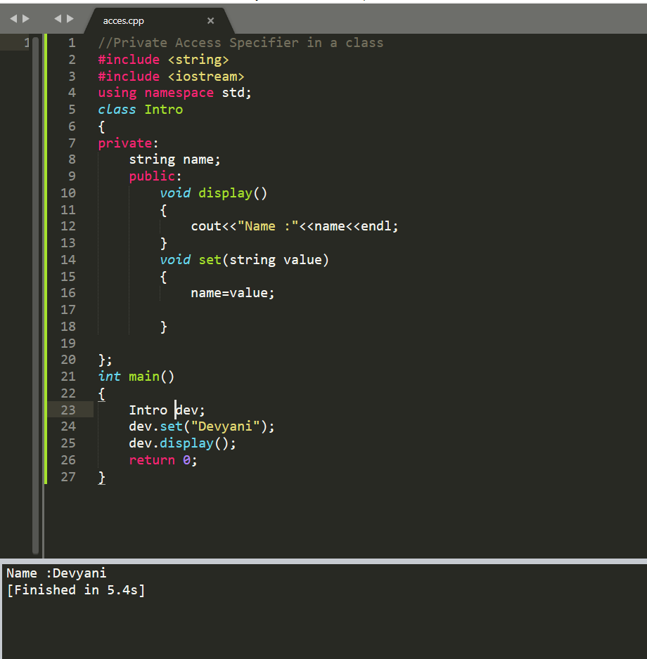

Class Constructor

Class constructor are constructor which are named same as the name of the class we don’t have to call the constructor when we assign object to the class it get automatically call .

